TutorTube: Intramolecular & Intermolecular Forces Spring 2020
Introduction
Hello and welcome to TutorTube, where The Learning Center’s Lead Tutors help you understand challenging course concepts with easy to understand videos. My name is Manal, Lead Tutor for sciences. In today’s video, we will explore different intramolecular and intermolecular forces. We will define, visualize, and compare all of these forces: covalent, ionic, metallic, London dispersion, dipole-dipole, hydrogen bonding, and ion-dipole. Let’s get started!
Definitions
To start, let’s define intramolecular and intermolecular. ‘Intra’ means within, so intramolecular forces occur within a molecule. ‘Inter’ means between, so intermolecular forces occur between molecules. The difference can be seen in this image.
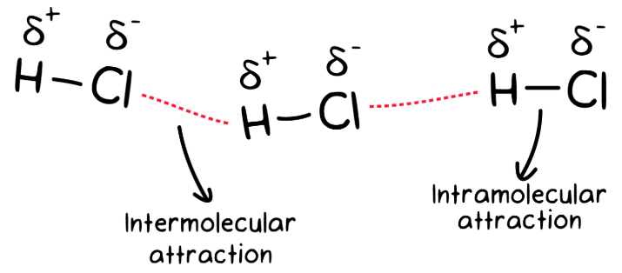
Image 1 (“Intramolecular and Intermolecular Forces”)
Covalent Bonds
The three types of intramolecular forces are covalent, ionic, and metallic bonding.
Covalent bonds occur between two nonmetals. In this type of bond, the atoms share electrons.
There are two types of covalent bonds: polar and nonpolar. Polar covalent bonds are between two atoms that have a difference in electronegativity. This difference in electronegativity causes unequal sharing of electrons, resulting in the more electronegative atom to have a partial negative charge, and the other atom to have a partial positive charge. In this image, the intramolecular attraction is a polar bond.
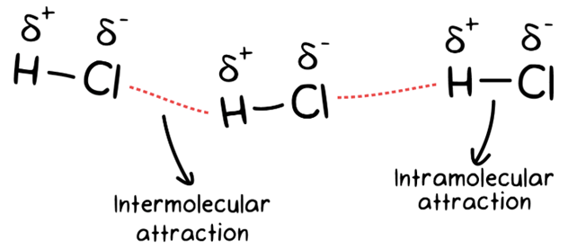
Image 2 (“Intramolecular and Intermolecular Forces”)
Nonpolar covalent bonds are between two atoms that have equal electronegativity, which is typically two of the same atoms, or between a carbon and a hydrogen. Electrons are shared equally, so no partial charges occur. Here is an example of a nonpolar bond.
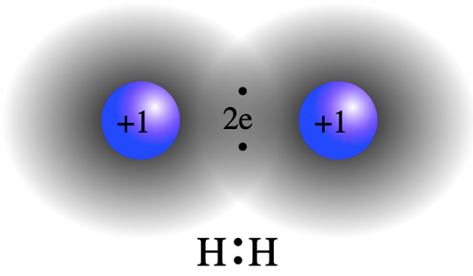
Image 3 (“Boundless Chemistry”)
Ionic Bonding
Ionic bonding occurs between a cation (which can be a metal or polyatomic cation) and an anion (which can be a nonmetal or polyatomic anion). In ionic bonds, electrons get completely transferred from the cation to the anion, resulting in full charges on the atoms, which you can see in this image.
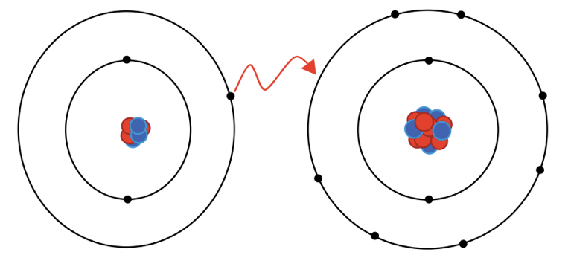
Image 4 (“Boundless Chemistry”)
Metallic Bonding
Metallic bonding occurs between metals. In this type of bonding, metal atoms pack closely together, and their electrons become detached and delocalized and can move freely. A strong force occurs between the delocalized electrons and the positive metal nuclei. It’s important to note that the metal atoms do not become cations, since, although the electron detaches, it’s still in the structure, as shown here.
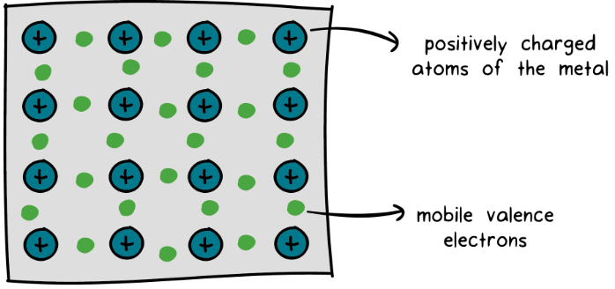
Image 5 (“Intramolecular and Intermolecular Forces”)
Intermolecular Forces
Now that we’ve gone through the intramolecular forces, let’s review the types of intermolecular forces.
Van der Waals forces are a category of intermolecular forces that includes London dispersion and dipole-dipole interactions. Some sources also consider hydrogen bonding to be a Van der Waals force.
London dispersion forces are present between all molecules. They are a result of electron movement within the molecule, producing a temporary induced dipole with neighboring molecules. In other words, electrons move around within molecules, so there will be temporary partial positive and partial negative charges produced. London dispersion interactions occur between these partial charges on different molecules. Here is an example.
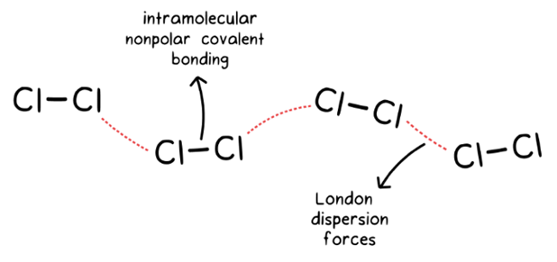
Image 6 ("Intramolecular and Intermolecular Forces")
Dipole-dipole interactions are present between polar molecules, which are molecules that have a permanent dipole moment. These molecules have one end that’s partially negative and one end that’s partially positive.
It’s important to know the difference between a polar bond and a polar molecule, since a molecule could have polar bonds and still be nonpolar. If a molecule has no polar bonds, then it’s a nonpolar molecule. If a molecule has at least one polar bond, then it may or may not be a polar molecule. For molecules with one central atom, if the molecule is unsymmetrical, or has a lone pair of electrons on the central atom, then it is a polar molecule.
Because polar molecules have partially charged ends, the interactions will occur between partial positive and partial negative charges on different molecules. You can see that in this image.
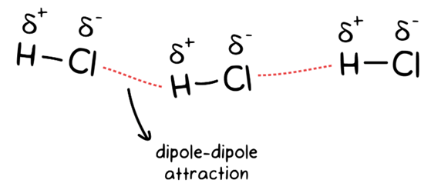
Image 7 ("Intramolecular and Intermolecular Forces")
Hydrogen bonding occurs between molecules containing a hydrogen bonded to fluorine, oxygen, or nitrogen. These three atoms are especially electronegative compared to hydrogen, so they will create a particularly strong dipole, resulting in a stronger interaction between molecules. The presence of hydrogen bonding in a molecule indicates a high boiling point, since it will take a lot of energy to overcome this interaction. Here is an example of a hydrogen bond.
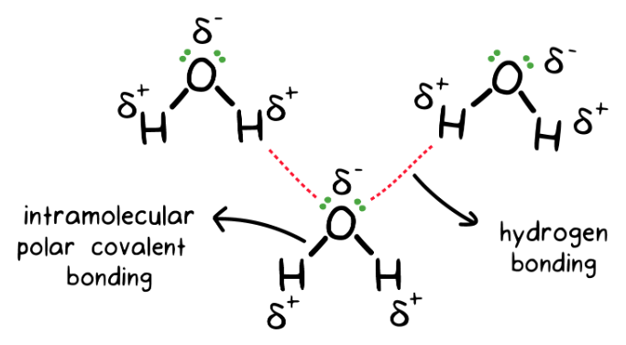
Image 8 ("Intramolecular and Intermolecular Forces")
Another type of intermolecular force is ion-dipole, which occurs between an ionic and a polar compound. There are two attractive forces in ion-dipole: (1) between a cation and the partial negative end of a polar molecule (shown in Image 9), and (2) between an anion and the partial positive end of a polar molecule.
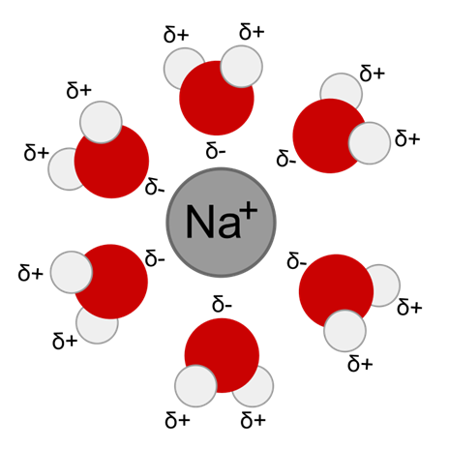
Image 9 (Madhu)
Generally, intramolecular forces are stronger than intermolecular forces. Within intermolecular forces, ion-dipole is the strongest, followed by hydrogen bonding, then dipole-dipole, and then London dispersion.
Here is a summary of the forces we went over in this video:
- Intramolecular forces
  - Covalent
    - Polar covalent
    - Nonpolar covalent
  - Ionic
  - Metallic
- Intermolecular forces
  - London dispersion
  - Dipole-dipole
  - Hydrogen bonding
  - Ion-dipole

Here are sources of the images used in this video. Thank you for watching TutorTube! I hope you enjoyed this video. Please subscribe to our channel for more exciting videos. Check out the links in the description below for more information about The Learning Center and follow us on social media. See you next time!
References
Images 1, 2, 5-8: “Intramolecular and Intermolecular Forces.” Khan Academy, https://creativecommons.org/licenses/by-nc-sa/4.0/.
Image 3: “The Covalent Bond.” Boundless Chemistry, https://courses.lumenlearning.com/boundless-chemistry/chapter/the-covalent-bond/.
Image 4: “The Ionic Bond.” Boundless Chemistry, https://courses.lumenlearning.com/boundless-chemistry/chapter/the-ionic-bond/.
Images 9: Madhu. “Difference Between Ion Dipole and Diploe Dipole Forces.” Difference Between, 2019, https://www.differencebetween.com/difference-between-ion-dipole-and-vs-dipole-dipole-forces/.

